**Software Development Life Cycle**

**(SDLC)**

System Development Life Cycle (SDLC) **vs** Software Development Life Cycle (SDLC)

Software Development Life Cycle (SDLC) Processes:

* Planning *(gathering requirements)*
* Analysis *(processing)*
* Design *(designing solutions)*
* Development & Implementation
* Testing
* Deployment *(launching)*
* 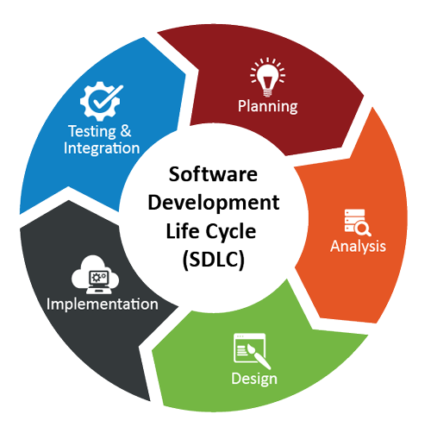Maintenance

**Methodologies**

* Waterfall Model
* Spiral Model
* Incremental Model
* Prototyping
* Agile
  + Scrum Model
  + Rapid Application Development (RAD)

**Waterfall Model**

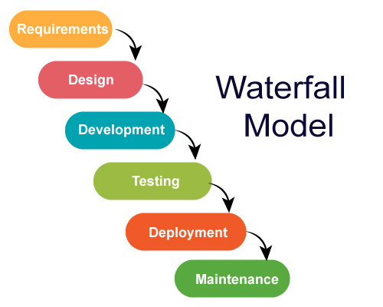

**Spiral Model**



**Incremental Model**

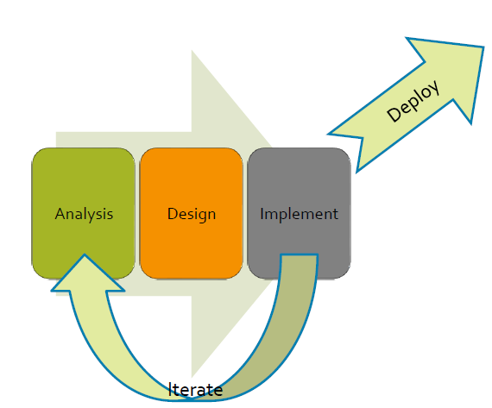

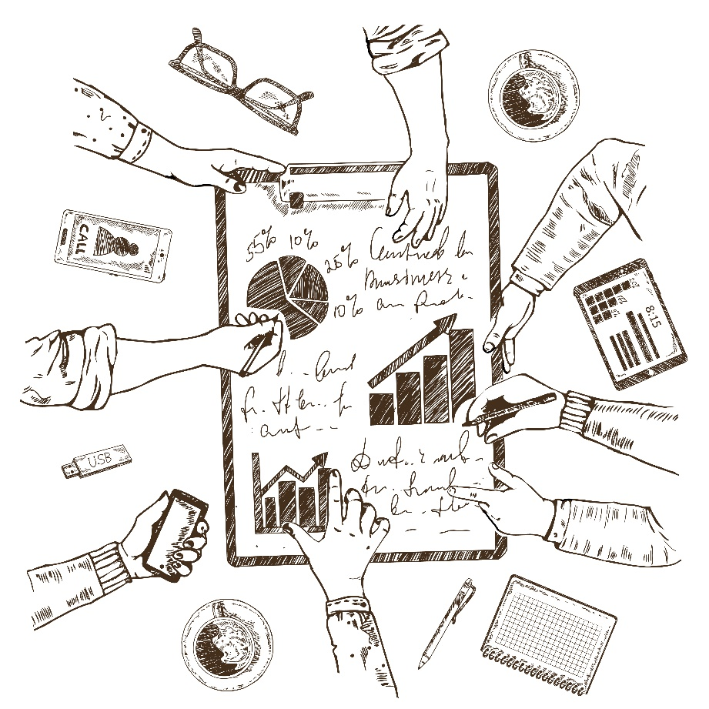

**Prototyping**

**Scrum Model (Agile)**



**Rapid Application Development (RAD)**